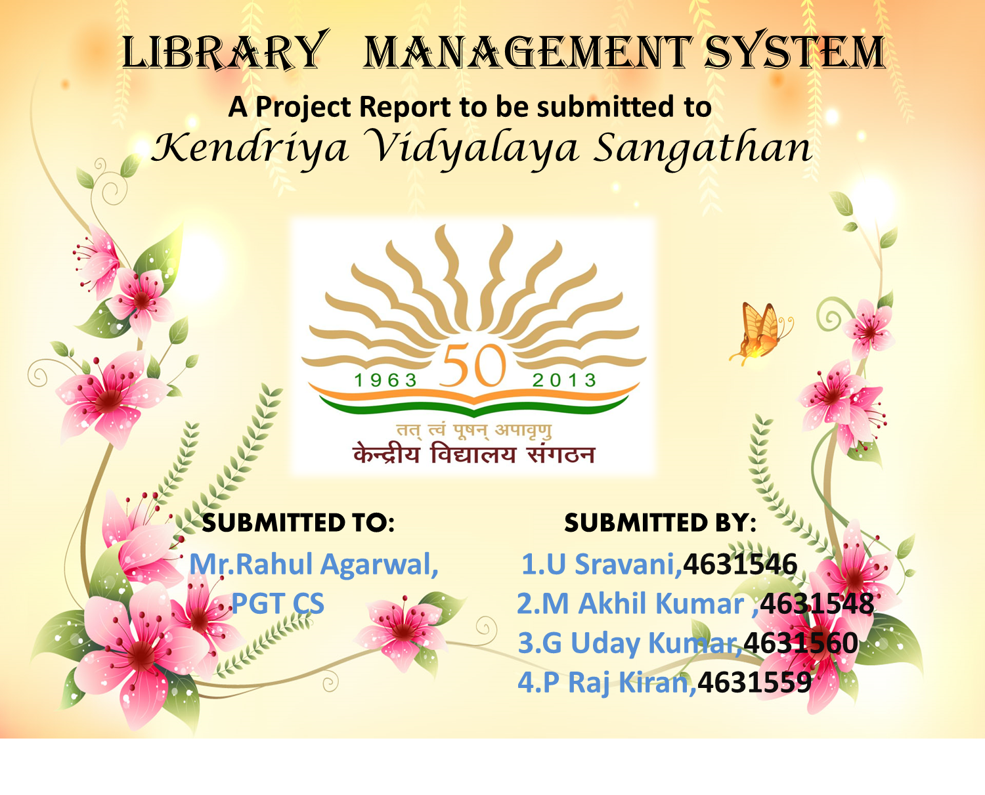

**Certificate**

This is to be certified that the Information Practices project

entitled “Library Management System” is the bonafide work carried

out by U Sravani,M Akhil Kumar,G Uday Kumar,P Raj Kiran

students of Class XII-A ,Kendriya Vidyalaya Ongole for the Academic

year 2014-15

Teacher IN-Charge: Principal:

CH.Prasad Rao,

Kendriya vidyalaya Ongole

**ACKNOWLEDGEMENT**

I express my sincere and heartfelt gratitude to **Mr.Rahul Agarwal,PGT Computers**, for his guidance and supervision at all levels of my Project work. He slowly and convincingly conveyed a spirit of knowledge in regard to IP subject and project in us. He helped us in understanding various topics of the IP project and in its accomplishment. I am indebted him for his valuable suggestions and sustained help in completion of my Project work.

I express my sincere gratitude to **Sri.CH Prasad Rao, Principal** who provided us latest equipment with good and fast working condition to accomplish our work in time.

In addition, I also thank all the members of my project who has supported me to generate my project work and also I want to thank my brother who have provided me few ideas to enlighten my Project .

**Content**

1. INTRODUCTION

1. FEATURES OF THIS PROJECT
2. REQUIREMENTS

1. BACK END(MySQL )
2. FRONT END(java)

1. OUTPUT SCREENSHOTS
2. BIBLIOGRAPHY

INTRODUCTION

Library is regarded as the brain of any institute; many institute understand the importance of the library to the growth of the institute and their esteem users(Students). The Library management system is crucial to the operation of the library and to the provision of services to users.

Library project system that offers many flexible and convenient features,allowing librarians and the library users to maximize time and efficiency.Library system gives all the detailed information users,staff and books.It will track on the books which are available in library and books issued to the people.It stores the user’s details and the date of the book taken .It also shows which books are to be returned.

FEATURES OF LIBRARY MANAGEMENT SYSTEMS

* Only basic knowledge of computer is required for operation of Library Management system .As it is user-friendly application interface.
* Library management system is customizable and user Configurable.
* This is used for normal reporting as well as Administration and staff development purpose.
* Keeps details of the user
* Keeps record of the Books taken and easy access of any book.
* Configurable as per user’s requirements.
* Eliminates duplication of efforts
* Safer means of storing and keeping track of the information
* More accurate and faster results from statistical analyses.
* More reliable security for sensitive and confidential information

REQUIREMENTS

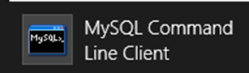 Mysql(Back end):- This is used to store all the data which consist of database and tables.

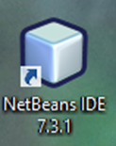 Java Netbeans(Front end):- This acts as a platform for the user to access easily.

MYSQL(Backend)

Database : 1. Surk

Tables: 1.Books 2.SignUp 3.TakeHome

Following are the structure and codes of the tables:

1)Books.

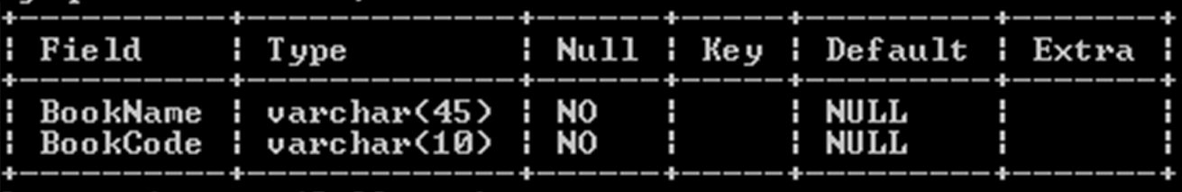

**Code:** **Create table books (BookName varchar(45),BookCode varchar(10));**

2)SignUp.

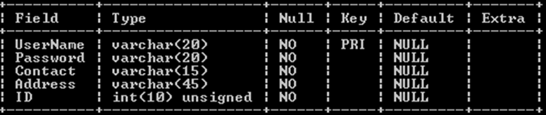

**Code:**Create table signup(UserName varchar(20),Password varchar(20),Contact Varchar(15),Address varchar(45),ID integer(10));

3)TakeHome.

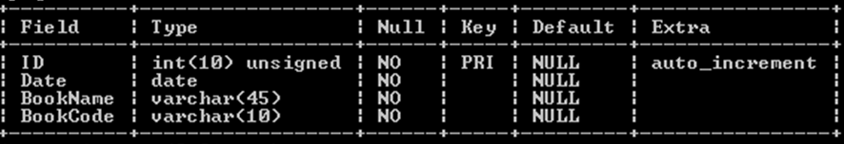

**Code:** Create table takehome(ID integer(10),Date date,BookName varchar(45),BookCode varchar(10));

Enter the records as given in the below sreenshot:

For Books Table:

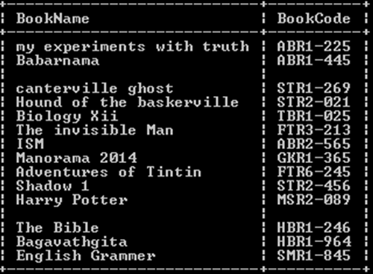

Insert into books value(‘BookName’,’Bookcode’);

Similarly create some more records.Using the above code:

Eg:- Take the second row from the above records ,the code will be as follows:

Insert into books value(‘Babarnama’,’ABR1-445’);

The remaining tables SignUp and TakeHome will be updated during the run time of the program by the user.

Front End (JAVA)



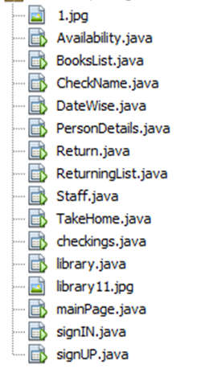

This is the screenshot of the Frames which are used in this program

You need to import the following things as per the requirements in each frame

* import java.sql.Connection;
* import java.sql.DriverManager;
* import java.sql.ResultSet;
* import java.sql.Statement;
* import javax.swing.table.DefaultTableModel;

Following are the sreen shots and names of the design views which are used in the project

1.Library Frame

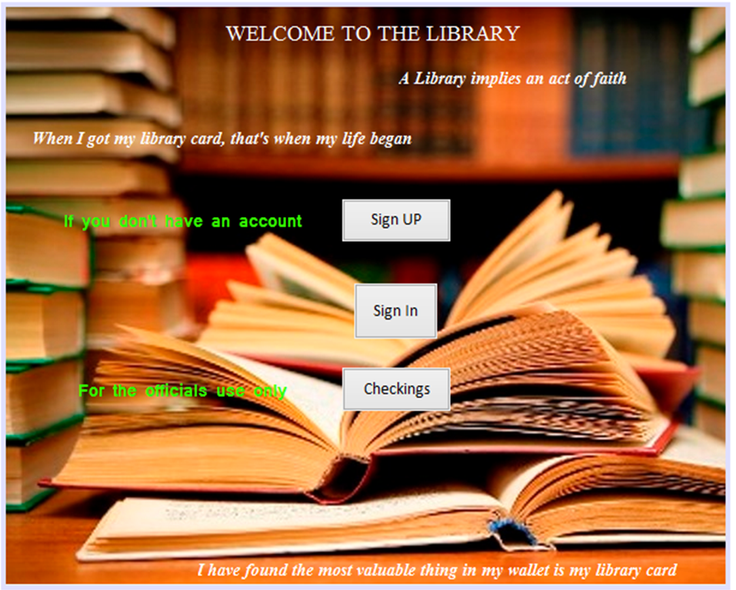

**Button1**

**Button3**

**Button2**

private void jButton1ActionPerformed(java.awt.event.ActionEvent evt) {

new signUP().setVisible(true);

this.dispose();

}

private void jButton2ActionPerformed(java.awt.event.ActionEvent evt) {

new signIN().setVisible(true);

this.dispose();

}

private void jButton3ActionPerformed(java.awt.event.ActionEvent evt) {

new Staff().setVisible(true);

this.dispose();

}

2.SignUp Frame

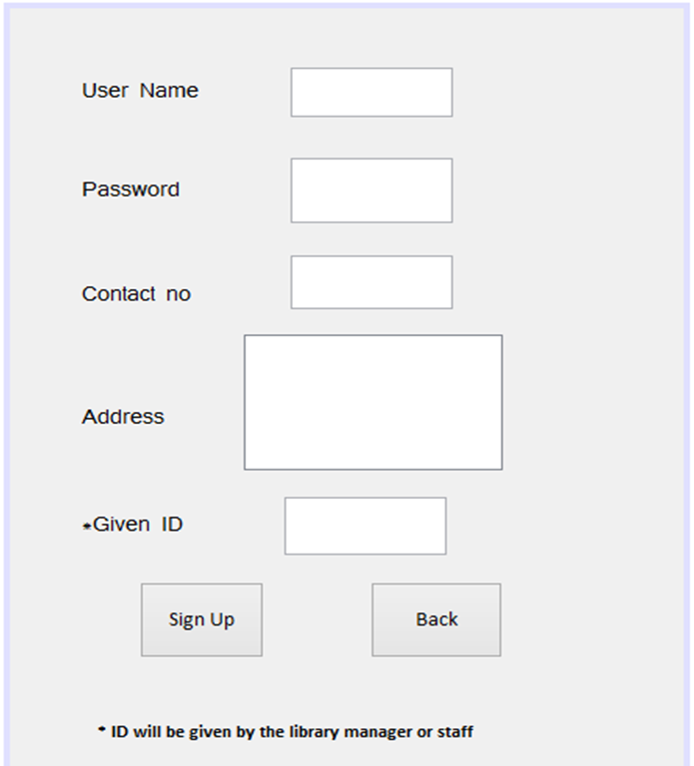

**PasswordField1**

**TextField1**

**TextField2**

**TextArea1**

**TextField3**

**Labels**

**Button1**

**Button2**

private void jButton1ActionPerformed(java.awt.event.ActionEvent evt) {

String UserName=jTextField1.getText();

String Password=jPasswordField1.getText();

String Contact=jTextField2.getText();

String Address=jTextArea1.getText();

String ID=jTextField3.getText();

if (UserName.isEmpty())

{

JOptionPane.showMessageDialog(rootPane, "Please Enter Your

UserName");

}

else if(Password.isEmpty())

{

JOptionPane.showMessageDialog(rootPane, "Please Enter Your Password");

}

else if(Contact.isEmpty())

{

JOptionPane.showMessageDialog(rootPane, "Please Enter Your contact");

}

else if(Address.isEmpty())

{

JOptionPane.showMessageDialog(rootPane, "Please Enter Your Address");

}

else if(ID.isEmpty())

{

JOptionPane.showMessageDialog(rootPane, "Please Enter Your Given ID");

}

{

try

{

Class.forName("java.sql.DriverManager");

java.sql.Connection con=(java.sql.Connection)

DriverManager.getConnection("jdbc:mysql://localhost:3306/surk","

root","kv");

java.sql.Statement st=(java.sql.Statement)con.createStatement();

String query ="insert into signup value('"+UserName+"','"+Password+

"','"+Contact+"','"+Address+"','"+ID+"');";

st.executeUpdate(query);

jTextField1.setText("");

jTextField2.setText("");

jTextField3.setText("");

jTextArea1.setText("");

jPasswordField1.setText("");

JOptionPane.showMessageDialog(this,"Your membership has been

successfully created");

}

catch (Exception e)

{

JOptionPane.showMessageDialog(rootPane, e.getMessage());

}

}

}

private void jButton2ActionPerformed(java.awt.event.ActionEvent evt) {

new library().setVisible(true);

this.dispose();

}

3.SignIN Frame

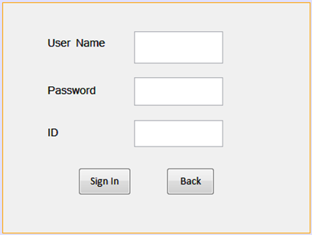

**TextField1**

**PasswordField1**

**TextField2**

**Button2**

**Button1**

private void jButton1ActionPerformed(java.awt.event.ActionEvent evt) {

String UserName=jTextField1.getText();

String Password=jPasswordField1.getText();

String ID=jTextField2.getText();

if(UserName.isEmpty())

{

JOptionPane.showMessageDialog(rootPane, "Please Enter UserName");

}

else if(Password.isEmpty())

{

JOptionPane.showMessageDialog(rootPane, "Please Enter Your Password");

}

else if(ID.isEmpty())

{

JOptionPane.showMessageDialog(rootPane, "Please Enter Your ID no");

}

else

{

try

{

Class.forName("java.sql.DriverManager");

java.sql.Connection con=(java.sql.Connection)

DriverManager.getConnection("jdbc:mysql://localhost:3306/surk","root","kv");

java.sql.Statement st=(java.sql.Statement)con.createStatement();

String query ="select ID from signup where UserName='"+UserName+"' and Password='"+Password+"' and ID='"+ID+"';";

st.executeQuery(query);

ResultSet rs=st.executeQuery(query);

if(rs.next())

{

new mainPage().setVisible(true);

this.dispose();

}

else

JOptionPane.showMessageDialog(rootPane, "Your username,password and ID does not match");

}

catch (Exception e)

{

JOptionPane.showMessageDialog(rootPane, e.getMessage());

}

}

I=jTextField2.getText();

name=jTextField1.getText();

}

private void jButton2ActionPerformed(java.awt.event.ActionEvent evt) {

new library().setVisible(true);

this.dispose();

}

4.Main Page Frame

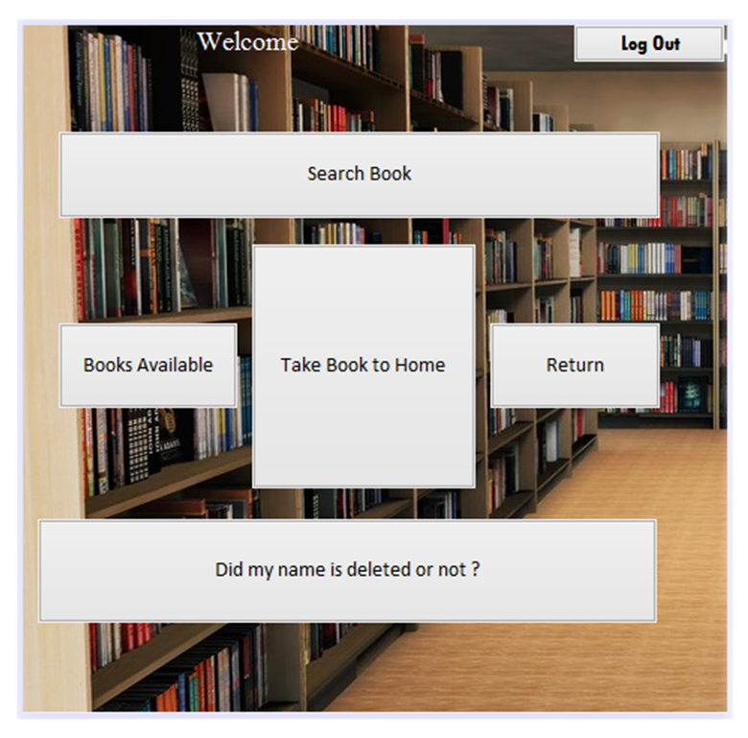

**Button5**

**Button4**

**Button3**

**Button2**

**Button1**

**Button6**

private void jButton3ActionPerformed(java.awt.event.ActionEvent evt) {

new TakeHome().setVisible(true);

this.dispose();

}

private void jButton1ActionPerformed(java.awt.event.ActionEvent evt) {

new Availability().setVisible(true);

this.dispose();

}

private void jButton5ActionPerformed(java.awt.event.ActionEvent evt) {

new BooksList().setVisible(true);

this.dispose();

}

private void jButton2ActionPerformed(java.awt.event.ActionEvent evt) {

new Return().setVisible(true);

this.dispose();

}

private void jButton4ActionPerformed(java.awt.event.ActionEvent evt) {

new CheckName().setVisible(true);

this.dispose();

}

private void jButton6ActionPerformed(java.awt.event.ActionEvent evt) {

new library().setVisible(true);

this.dispose();

}

private void formWindowGainedFocus(java.awt.event.WindowEvent evt) {

jLabel2.setText(""+signIN.name);

5.Availability Frame

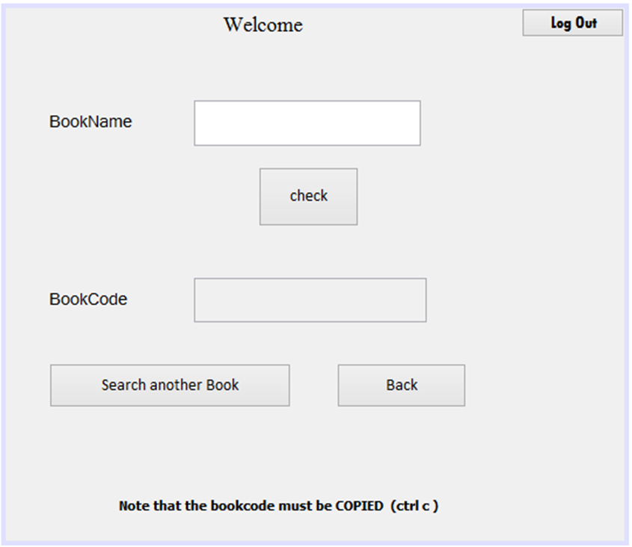

**Button2**

**Button4**

**TextField2**

**Button1**

**TextField1**

**Button5**

private void jButton1ActionPerformed(java.awt.event.ActionEvent evt) {

String BookName=jTextField1.getText();

if(BookName.isEmpty())

{

JOptionPane.showMessageDialog(rootPane, "Please Enter Book Name");

}

else

{

try

{

Class.forName("java.sql.DriverManager");

java.sql.Connection con=(java.sql.Connection)

DriverManager.getConnection("jdbc:mysql://localhost:3306/surk",

"root","kv");

java.sql.Statement st=(java.sql.Statement)con.createStatement();

String query ="select BookCode from books where

BookName='"+BookName+"';";

st.executeQuery(query);

ResultSet rs=st.executeQuery(query);

if(rs.next())

{

String BookCode=rs.getString("BookCode");

jTextField2.setText(BookCode);

}

else

JOptionPane.showMessageDialog(rootPane, "Sorry Your Book is Not

Available");

}

catch (Exception e)

{

JOptionPane.showMessageDialog(rootPane, e.getMessage());

}

}

}

private void jButton2ActionPerformed(java.awt.event.ActionEvent evt) {

jTextField1.setText("");

jTextField2.setText("");

}

private void jButton4ActionPerformed(java.awt.event.ActionEvent evt) {

new mainPage().setVisible(true);

this.dispose();

}

private void jButton5ActionPerformed(java.awt.event.ActionEvent evt) {

new library().setVisible(true);

this.dispose();

}

private void formWindowGainedFocus(java.awt.event.WindowEvent evt) {

jLabel4.setText(""+signIN.name);

}

6.BookList Frame

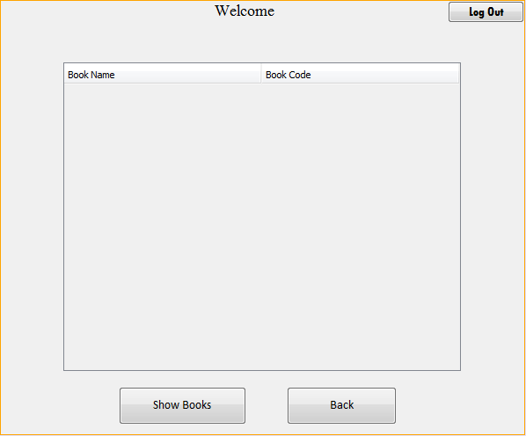

**Button1**

**Button2**

**Table1**

**Button3**

private void jButton1ActionPerformed(java.awt.event.ActionEvent evt) {

DefaultTableModel model=(DefaultTableModel)

jTable1.getModel();

try

{

Class.forName("java.sql.DriverManager");

java.sql.Connection con=(java.sql.Connection)

DriverManager.getConnection("jdbc:mysql://localhost:3306/surk","root

","kv");

java.sql.Statement st=(java.sql.Statement)con.createStatement();

String query="select * from books";

ResultSet rs=st.executeQuery(query);

while(rs.next())

{

String BookName =rs.getString("BookName");

String BookCode =rs.getString("BookCode");

model.addRow(new Object[] {BookName,BookCode});

}

}

catch (Exception e)

{

JOptionPane.showMessageDialog(this,e.getMessage());

}

jButton1.setEnabled(false);

}

private void jButton2ActionPerformed(java.awt.event.ActionEvent evt) {

new mainPage().setVisible(true);

this.dispose();

}

private void formWindowGainedFocus(java.awt.event.WindowEvent evt) {

jLabel2.setText(""+signIN.name);

}

private void jButton3ActionPerformed(java.awt.event.ActionEvent evt) {

new library().setVisible(true);

this.dispose();

}

7.TakeHome Frame

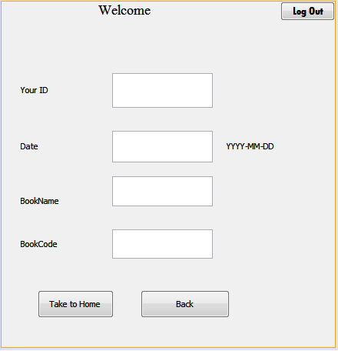

**Button1**

**TextField4**

**TextField3**

**TextField2**

**TextField1**

**Button4**

**Button3**

private void jButton1ActionPerformed(java.awt.event.ActionEvent evt) {

String ID=jTextField1.getText();

String Date=jTextField2.getText();

String BookName=jTextField3.getText();

String BookCode=jTextField4.getText();

if (ID.isEmpty())

{

JOptionPane.showMessageDialog(rootPane, "Please Enter Your ID");

}

else if(Date.isEmpty())

{

JOptionPane.showMessageDialog(rootPane, "Please Enter Date");

}

else if(BookName.isEmpty())

{

JOptionPane.showMessageDialog(rootPane, "Please Enter Book Name");

}

else if(BookCode.isEmpty())

{

JOptionPane.showMessageDialog(rootPane, "Please Enter Book Code");

}

{

try

{

Class.forName("java.sql.DriverManager");

java.sql.Connection con=(java.sql.Connection)

DriverManager.getConnection("jdbc:mysql://localhost:3306/surk","root

","kv");

java.sql.Statement st=(java.sql.Statement)con.createStatement();

String query ="insert into takehome value('"+ID+"','"+Date+"',

'"+BookName+"','"+BookCode+"');";

st.executeUpdate(query);

jTextField1.setText("");

jTextField2.setText("");

jTextField3.setText("");

jTextField4.setText("");

}

catch (Exception e)

{

JOptionPane.showMessageDialog(rootPane, e.getMessage());

}

try

{

Class.forName("java.sql.DriverManager");

Connection con=(Connection)

DriverManager.getConnection("jdbc:mysql://localhost:3306/surk","root

","kv");

Statement st = (Statement) con.createStatement();

String query="delete from books where BookCode='"+BookCode+"';";

st.executeUpdate(query);

}

catch(Exception e)

{

JOptionPane.showMessageDialog(this, e.getMessage());

}

JOptionPane.showMessageDialog(this, "Thank You,Now you can take the

book to your home");

}

}

private void jButton3ActionPerformed(java.awt.event.ActionEvent evt) {

new mainPage().setVisible(true);

this.dispose();

}

private void jButton4ActionPerformed(java.awt.event.ActionEvent evt) {

new library().setVisible(true);

this.dispose();

}

private void formWindowGainedFocus(java.awt.event.WindowEvent evt) {

jTextField1.setText(""+signIN.I);

jLabel8.setText(""+signIN.name);

}

8.Return Frame

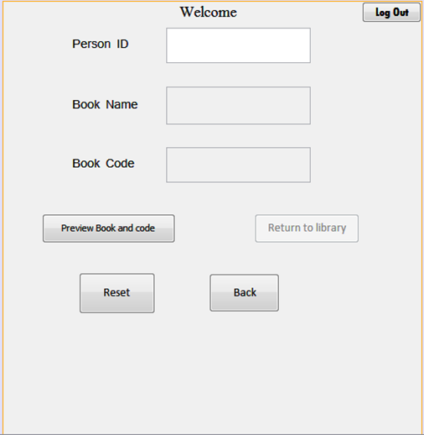

**Button6**

**Button3**

**Button4**

**Button1**

**TextField3**

**TextField2**

**TextField1**

**Button5**

private void jButton4ActionPerformed(java.awt.event.ActionEvent evt) {

new mainPage().setVisible(true);

this.dispose();

}

private void jButton1ActionPerformed(java.awt.event.ActionEvent evt) {

String BookName=jTextField1.getText();

String BookCode=jTextField2.getText();

String PersonID=jTextField3.getText();

try

{

Class.forName("java.sql.DriverManager");

java.sql.Connection con=(java.sql.Connection)

DriverManager.getConnection("jdbc:mysql://localhost:3306/surk","root

","kv");

java.sql.Statement st=(java.sql.Statement)con.createStatement();

String query ="insert into books value('"+BookName+"','"+BookCode+"');";

st.executeUpdate(query);

jTextField1.setText("");

jTextField2.setText("");

}

catch (Exception e)

{

JOptionPane.showMessageDialog(rootPane, e.getMessage());

}

try

{

Class.forName("java.sql.DriverManager");

Connection con=(Connection)

DriverManager.getConnection("jdbc:mysql://localhost:3306/surk","root

","kv");

Statement st = (Statement) con.createStatement();

String query="delete from takehome where ID='"+PersonID+"';";

st.executeUpdate(query);

jTextField3.setText("");

}

catch(Exception e)

{

JOptionPane.showMessageDialog(this, e.getMessage());

}

JOptionPane.showMessageDialog(this, "You have successfully returned book to

library");

}

private void jButton3ActionPerformed(java.awt.event.ActionEvent evt) {

jButton1.setEnabled(false);

jTextField1.setText("");

jTextField2.setText("");

jTextField3.setText("");

}

private void jButton5ActionPerformed(java.awt.event.ActionEvent evt) {

new library().setVisible(true);

this.dispose();

}

private void formWindowGainedFocus(java.awt.event.WindowEvent evt) {

jLabel5.setText(""+signIN.name);

jTextField3.setText(""+signIN.I);

}

private void jButton6ActionPerformed(java.awt.event.ActionEvent evt) {

String PersonID=jTextField3.getText();

try

{

Class.forName("java.sql.DriverManager");

java.sql.Connection con=(java.sql.Connection)

DriverManager.getConnection("jdbc:mysql://localhost:3306/surk","root

","kv");

java.sql.Statement st=(java.sql.Statement)con.createStatement();

String query ="select BookCode,BookName from TakeHome where

ID='"+PersonID+"';";

st.executeQuery(query);

ResultSet rs=st.executeQuery(query);

if(rs.next())

{

String BookName=rs.getString("BookName");

String BookCode=rs.getString("BookCode");

jTextField1.setText(BookName);

jTextField2.setText(BookCode);

jButton1.setEnabled(true);

}

else

JOptionPane.showMessageDialog(this, "You Already returned Book to

the library");

}

catch (Exception e)

{

JOptionPane.showMessageDialog(rootPane, e.getMessage());

}

}

9.CheckName

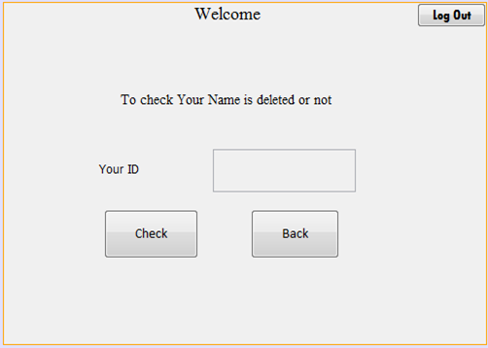

**Button1**

**Button2**

**TextField1**

**Button3**

private void jButton1ActionPerformed(java.awt.event.ActionEvent evt) {

String ID=jTextField1.getText();

try

{

Class.forName(“java.sql.DriverManager”);

java.sql.Connection con=(java.sql.Connection)

DriverManager.getConnection(“jdbc:mysql://localhost:3306/surk”

,”root ”,”kv”);

java.sql.Statement st=(java.sql.Statement)con.createStatement();

String query =”select ID from takehome where ID=’”+ID+”’;”;

st.executeQuery(query);

ResultSet rs=st.executeQuery(query);

if(rs.next())

{

JOptionPane.showMessageDialog(this, “Your name is not deleted”);

}

else

JoptionPane.showMessageDialog(rootPane, “Your name is deleted”);

}

catch (Exception e)

{

JoptionPane.showMessageDialog(rootPane, e.getMessage());

}

}

private void jButton2ActionPerformed(java.awt.event.ActionEvent evt) {

new mainPage().setVisible(true);

this.dispose();

}

private void jButton3ActionPerformed(java.awt.event.ActionEvent evt) {

new library().setVisible(true);

this.dispose();

}

private void formWindowGainedFocus(java.awt.event.WindowEvent evt) {

jTextField1.setText(“”+signIN.I);

jLabel4.setText(“”+signIN.name);

}

10.Staff Frame

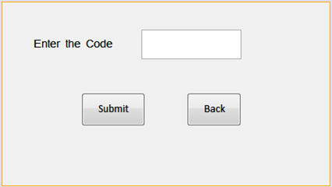

**Button1**

**Button2**

**PasswordField1**

private void jButton1ActionPerformed(java.awt.event.ActionEvent evt) {

String password=jPasswordField1.getText();

if

(password.equals("rajkiran"))

{new checkings().setVisible(true);}

else

{

JOptionPane.showMessageDialog(this, "The Password is incorrect");

}

this.dispose();

}

private void jButton2ActionPerformed(java.awt.event.ActionEvent evt) {

new library().setVisible(true);

this.dispose();

}

11.Checkings Frame

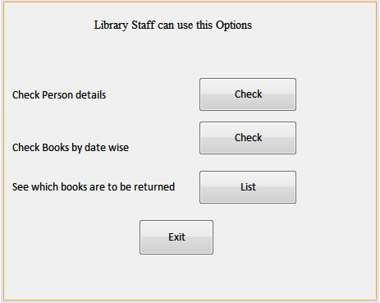

**Button1**

**Button2**

**Button3**

**Button4**

private void jButton1ActionPerformed(java.awt.event.ActionEvent evt) {

new PersonDetails().setVisible(true);

this.dispose();

}

private void jButton2ActionPerformed(java.awt.event.ActionEvent evt) {

new DateWise().setVisible(true);

this.dispose();

}

private void jButton3ActionPerformed(java.awt.event.ActionEvent evt) {

new ReturningList().setVisible(true);

this.dispose();

}

private void jButton4ActionPerformed(java.awt.event.ActionEvent evt) {

new library().setVisible(true);

this.dispose();

}

12.DateWise Frame

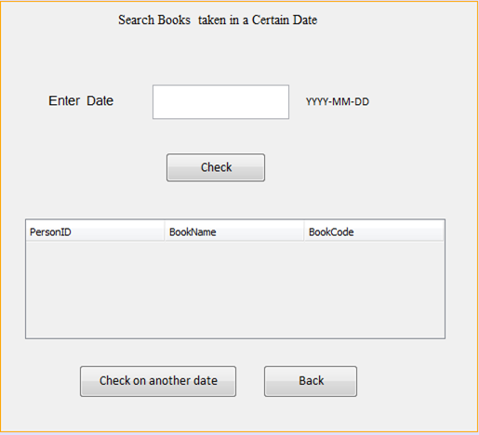

**Button3**

**Button2**

**Table1**

**Button1**

**TextField1**

private void jButton1ActionPerformed(java.awt.event.ActionEvent evt) {

String Date=jTextField1.getText();

DefaultTableModel model=(DefaultTableModel)

jTable1.getModel();

if(Date.isEmpty())

{

JOptionPane.showMessageDialog(rootPane, "Please Enter Date");

}

else

{

try

{

Class.forName("java.sql.DriverManager");

java.sql.Connection con=(java.sql.Connection)

DriverManager.getConnection("jdbc:mysql://localhost:3306/surk","root

","kv");

java.sql.Statement st=(java.sql.Statement)con.createStatement();

String query="select ID,Bookname,bookcode from takehome where

Date='"+Date+"'";

ResultSet rs=st.executeQuery(query);

if(rs.next())

{

String PersonID=rs.getString("ID");

String BookName =rs.getString("BookName");

String BookCode =rs.getString("BookCode");

model.addRow(new Object[] {PersonID,BookName,BookCode});

jButton1.setEnabled(false);

}

else

{

JOptionPane.showMessageDialog(rootPane, "No match Found");

}

}

catch (Exception e)

{

JOptionPane.showMessageDialog(this,e.getMessage());

}

}

}

private void jButton2ActionPerformed(java.awt.event.ActionEvent evt) {

new checkings().setVisible(true);

this.dispose();

}

private void jButton3ActionPerformed(java.awt.event.ActionEvent evt) {

jTextField1.setText("");

}

13.PersonDetails Frame

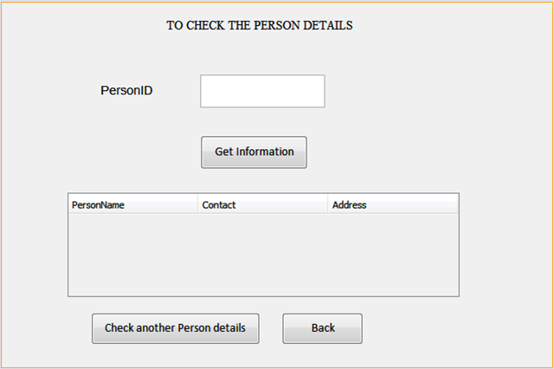

**Button3**

**Button2**

**Table1**

**Button1**

**TextField1**

private void jButton1ActionPerformed(java.awt.event.ActionEvent evt) {

String ID=jTextField1.getText();

DefaultTableModel model=(DefaultTableModel)

jTable1.getModel();

if(ID.isEmpty())

{

JOptionPane.showMessageDialog(rootPane, "Please Enter PersonID");

}

else

{

try

{

Class.forName("java.sql.DriverManager");

java.sql.Connection con=(java.sql.Connection)

DriverManager.getConnection("jdbc:mysql://localhost:3306/surk",

"root","kv");

java.sql.Statement st=(java.sql.Statement)con.createStatement();

String query="select username,contact,address from signup where

ID='"+ID+"'";

st.executeQuery(query);

ResultSet rs=st.executeQuery(query);

if(rs.next())

{

String UserName=rs.getString("UserName");

String Contact =rs.getString("Contact");

String Address =rs.getString("Address");

model.addRow(new Object[] {UserName,Contact,Address});

jButton1.setEnabled(false);

}

else

{

JOptionPane.showMessageDialog(rootPane, "No Person found with

such an ID");

}

}

catch (Exception e)

{

JOptionPane.showMessageDialog(this,e.getMessage());

}

}

}

private void jButton2ActionPerformed(java.awt.event.ActionEvent evt) {

new checkings().setVisible(true);

this.dispose();

}

private void jButton3ActionPerformed(java.awt.event.ActionEvent evt) {

jTextField1.setText("");

jButton1.setEnabled(true);

}

14.ReturningList Frame

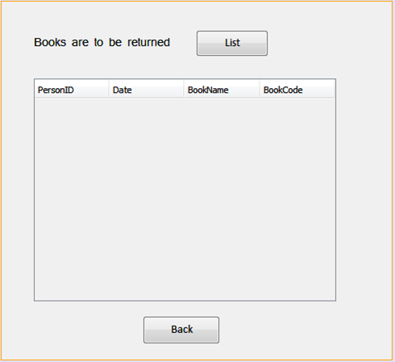

**Button2**

**Table1**

**Button1**

private void jButton1ActionPerformed(java.awt.event.ActionEvent evt) {

DefaultTableModel model=(DefaultTableModel)

jTable1.getModel();

try

{

Class.forName("java.sql.DriverManager");

java.sql.Connection con=(java.sql.Connection)

DriverManager.getConnection("jdbc:mysql://localhost:3306/surk","

root","kv");

java.sql.Statement st=(java.sql.Statement)con.createStatement();

String query="select * from Takehome";

ResultSet rs=st.executeQuery(query);

while(rs.next())

{

String PersonID =rs.getString("ID");

String Date =rs.getString("Date");

String BookName =rs.getString("BookName");

String BookCode =rs.getString("BookCode");

model.addRow(new Object[] {PersonID,Date,BookName,BookCode});

}

}

catch (Exception e)

{

JOptionPane.showMessageDialog(this,e.getMessage());

}

jButton1.setEnabled(false);

}

private void jButton2ActionPerformed(java.awt.event.ActionEvent evt) {

new checkings().setVisible(true);

this.dispose();

}

OUTPUT:

This is the first window you can see when run the project

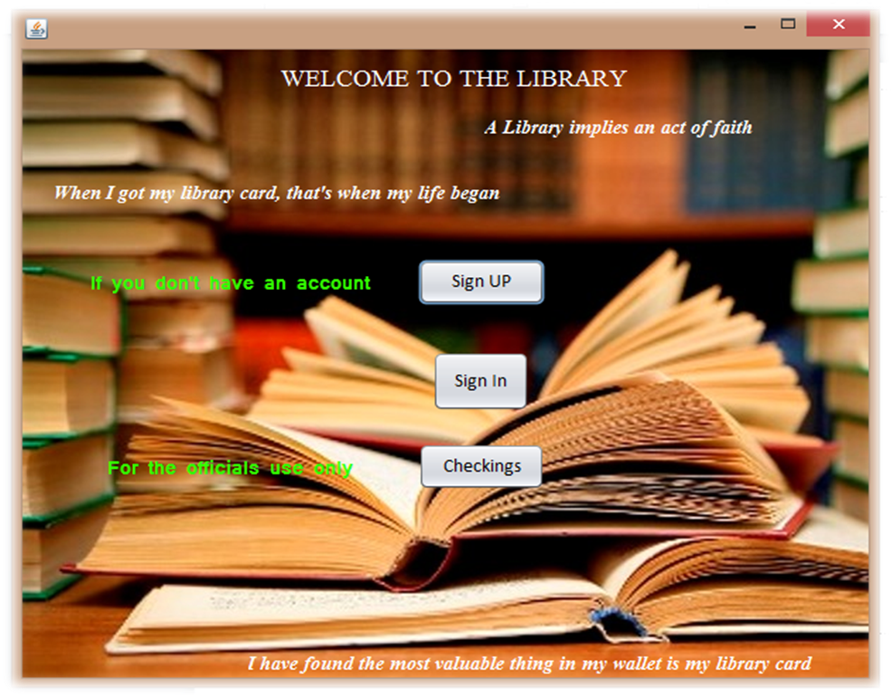

If you click on the Sign UP Button you can see the window which is on the next page

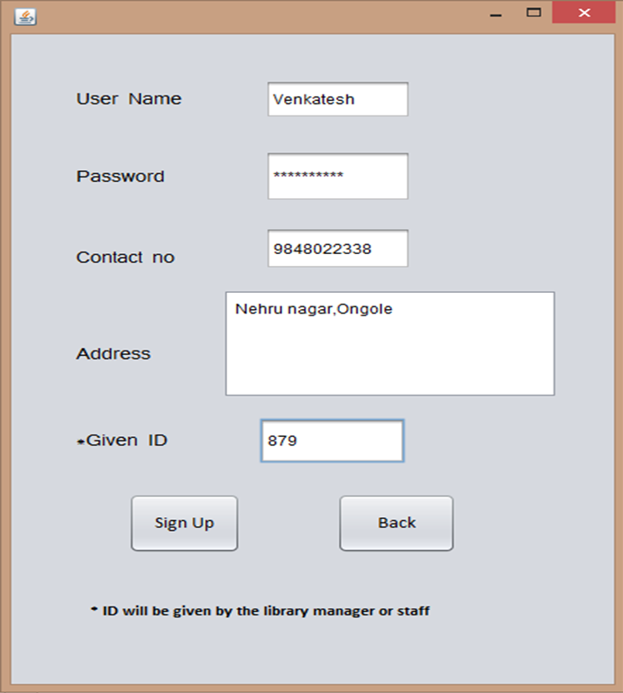

Enter the details on appropriate textfields , textarea and then click on the Sign Up button ,you can see the following Popup which shows that your membership has been created.

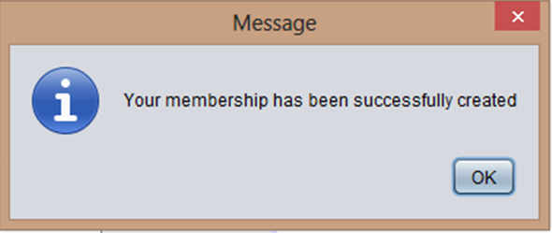

To go to Library frame just click on the Back button in Sign Up frame. Now click on the Sign In from Library frame You can see the below window

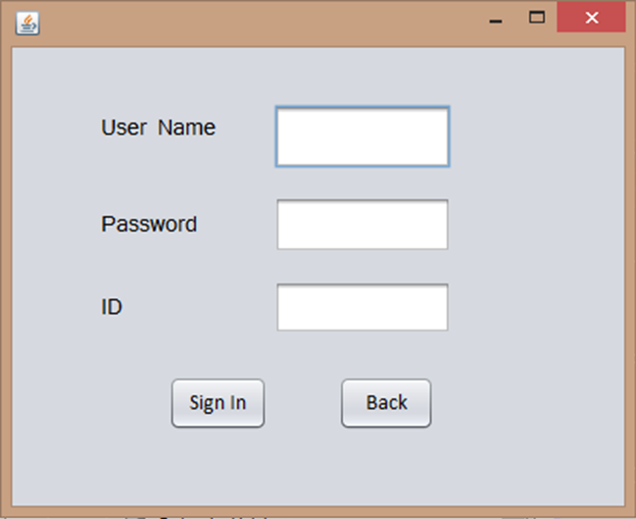

Enter Your membership details and click on the Sign In Button to use the Option of the library .If You Enter all the correct details and click on the Sign In button you can see the window which is on the next Page else you can see the below popup

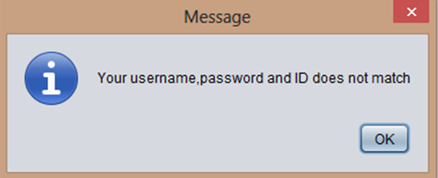

After Signing in you can see Log Out button in every frame you can click on it to get Log Out

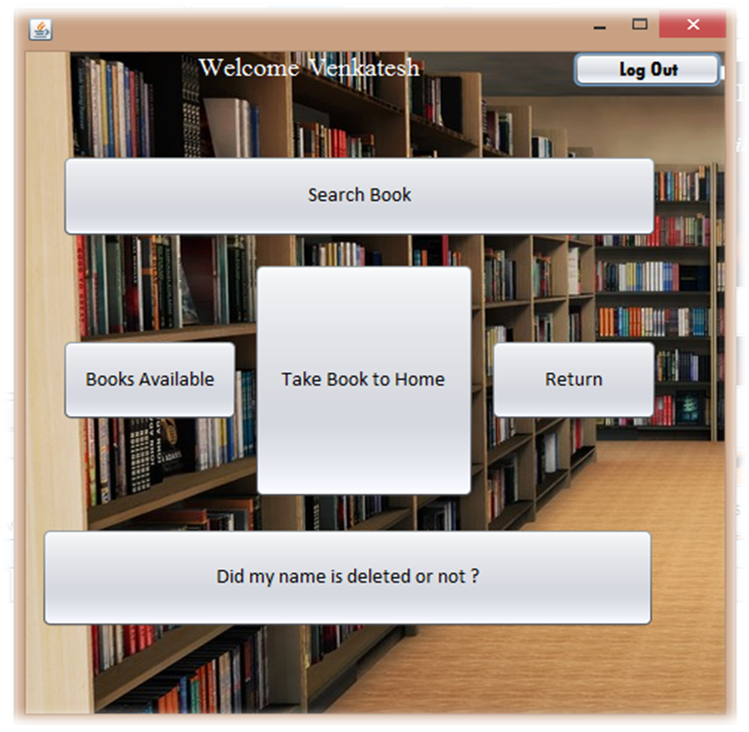

If you Click on the Search Books you can see the below window

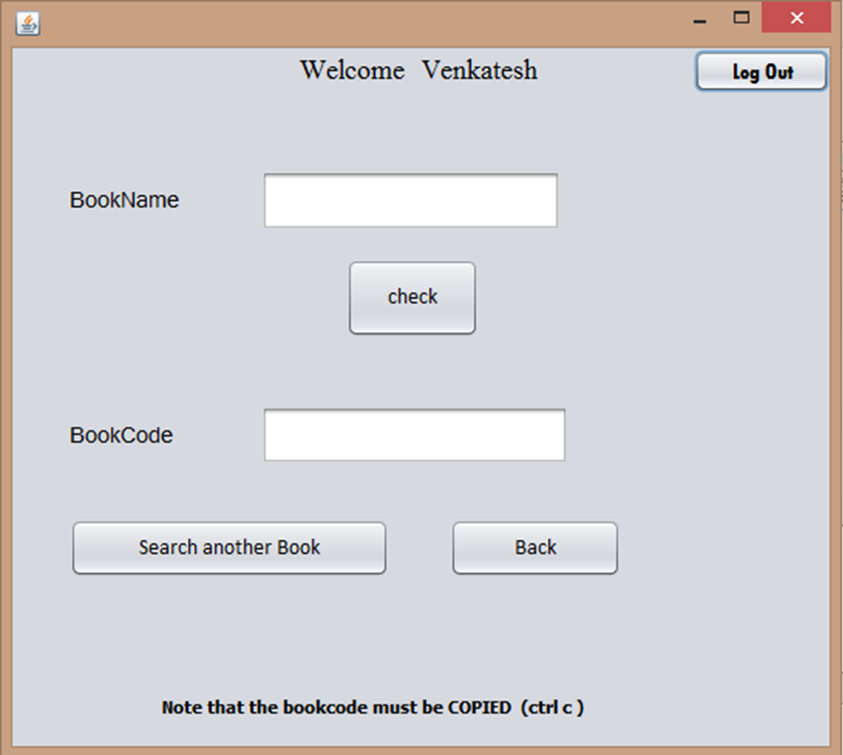

Enter the book name and click on check , if the book is available then it’s code will be given in the textField2 else it will show a message as the book is not available .To go move into main page click on the Back button

From the main page if you click on the Take Book To Home button you can see the below window

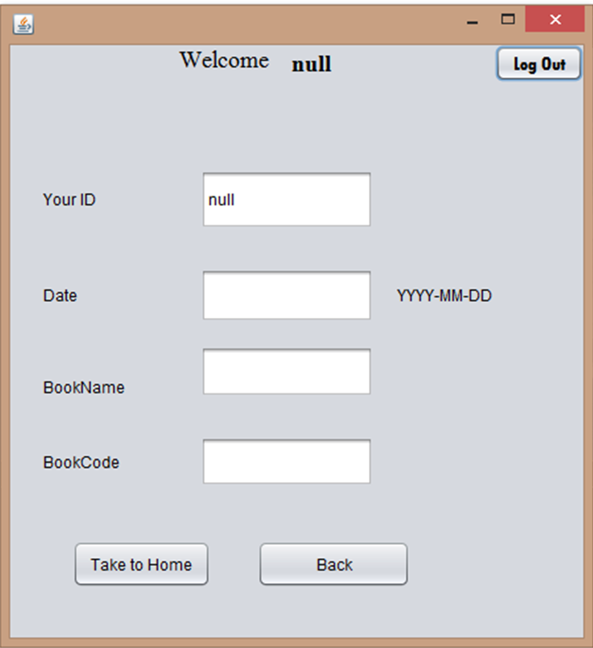

Instead of ‘null’ at the top you can see your name and in the textfield with ‘null’ you can see your ID .

Give all above mentioned details in their appropriate textfields and click on the Take To Home button then you can see the below popup.Click on the back button to go to main page

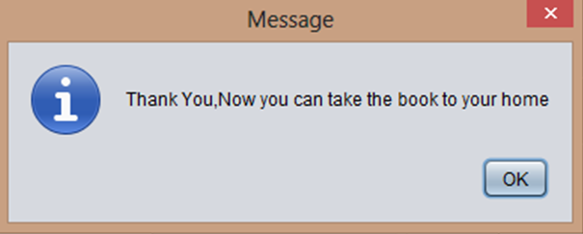

If you click on the Availability button from the Main page you can see the below window

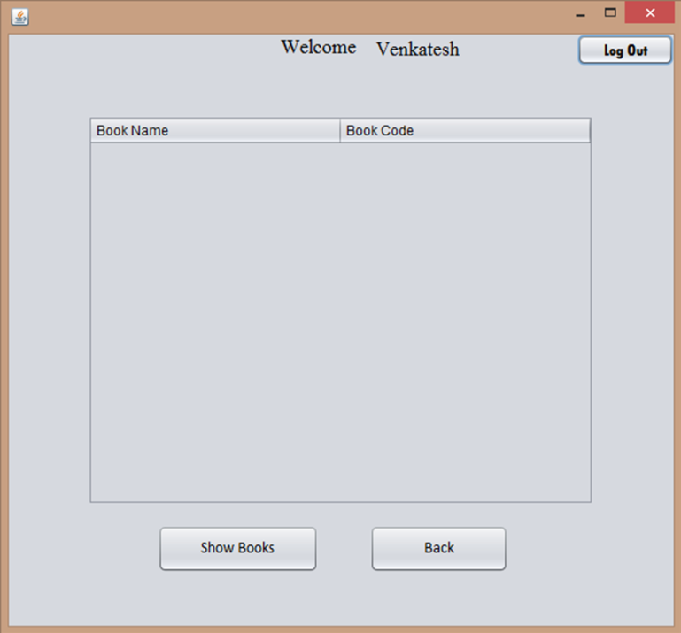

Instead of Venkatesh you can see your name.

Click on the Show Books Button to view the Available books.

To move to Main Page click on the back button.

To return a book to library click on the return button from the Main Page.Then you can see the window which is in next page

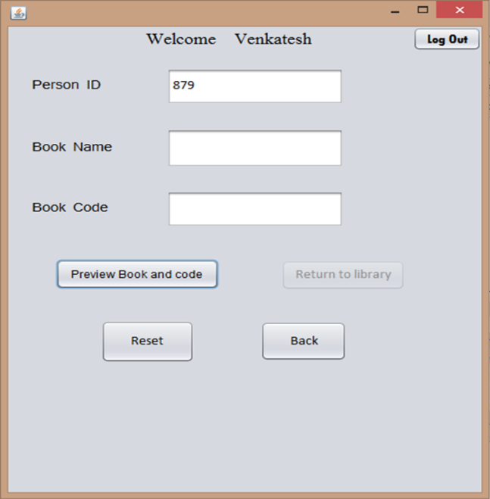

Instead of Venkatesh and the ID you can see Your name and your ID respectively.

To show books which you have taken click on the Preview Book and Code button.On clicking it you can see the button Return to Library will be enabled.Click on it to return to the Library.

Then you can see the following popup

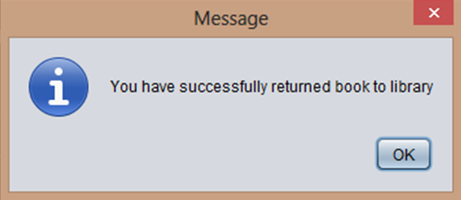

To move to Main Page click on the back button in Return Frame.

To check whether Your name is deleted or not ,Click on ‘Did My Name is Deleted or not?’ button from Main Page.

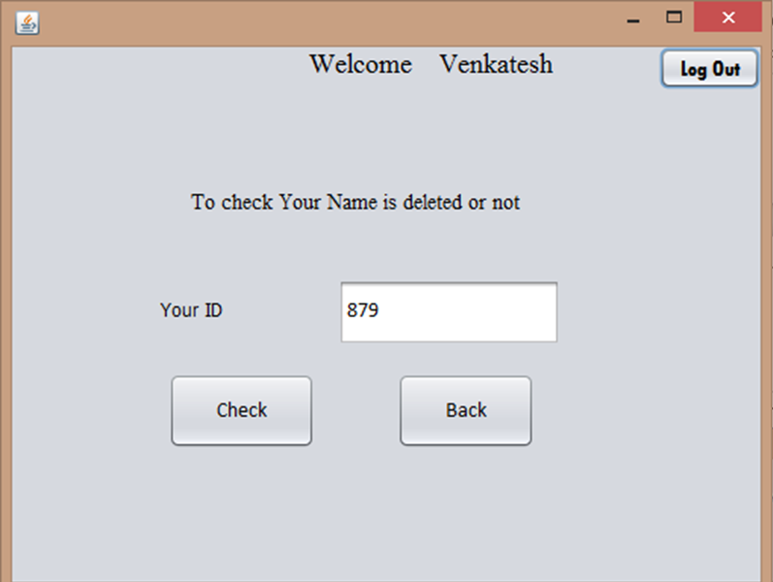

Instead of Venkatesh and ID you can see Your name and your ID respectively.

If you click on the Check Button you can see the following Messages as per the data

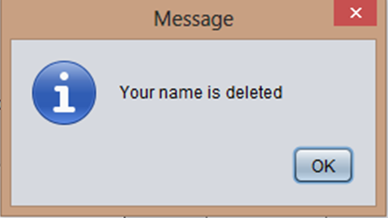

Click on the Log Out button to close the window.When you click on the Log Out button you can see the window which is in next page.



Now there is one more option which is useful for Library staff.

If you click on the Checkings button you can see the window which is in next page,then give the password and click on submit,then you can see the window which is in next page

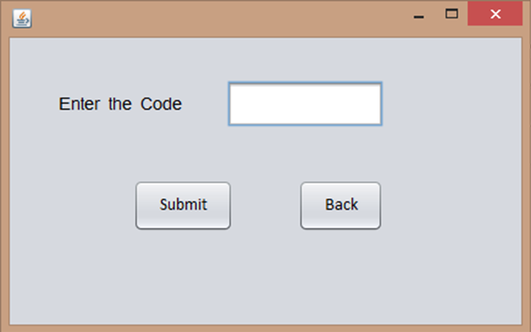

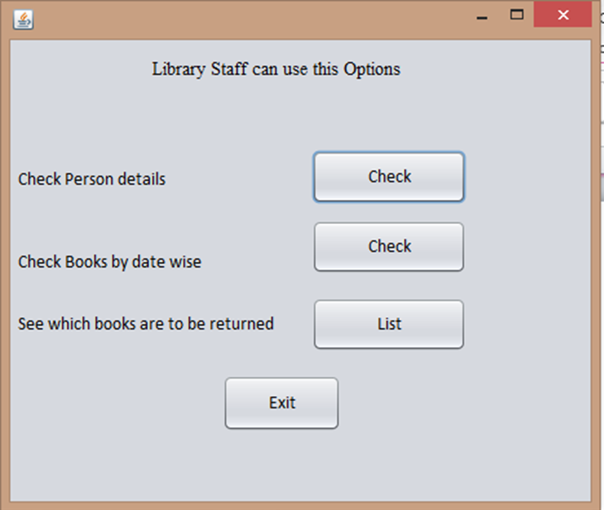

If you click on the first Check Button you can see the below window

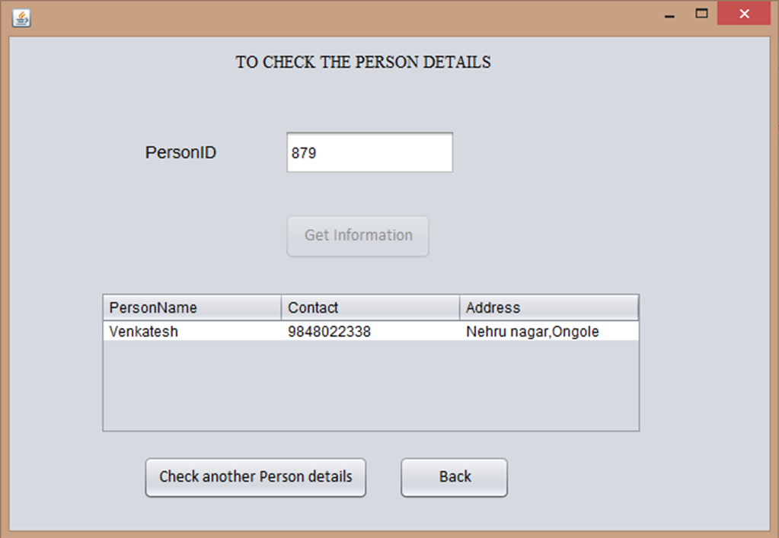

Enter Person ID and click on the Get Information Button ,if you want to check another Person’s details Click on the respective Button which is in the frame .

To go to Staff Usage Options click on the Back Button.

To check the books taken on a certain date click on the respective Check button in the Staff usage Frame,then you can see the below window.

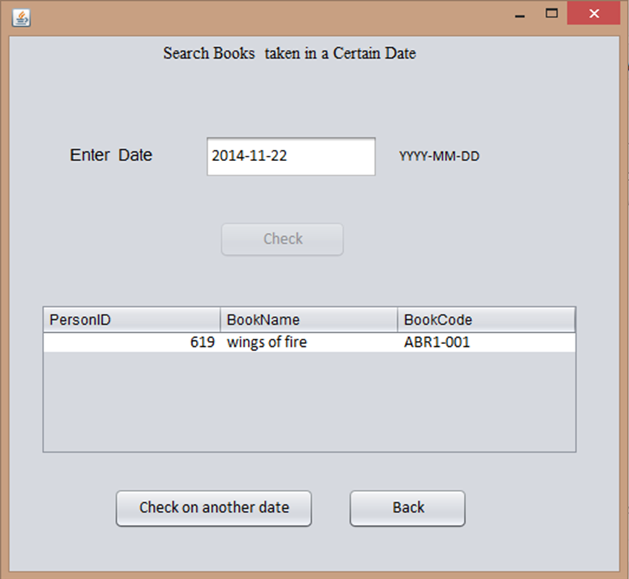

Enter the date in the textfield and click on the ‘Check’ button to know the information .Click on the ‘Check on another date’ button to clear textfield and set the check button enabled.

Click on the back button to move to Staff usage options.

To see what are the books to be returned, just click on the respective ‘List’ Button and then you can see the below window.

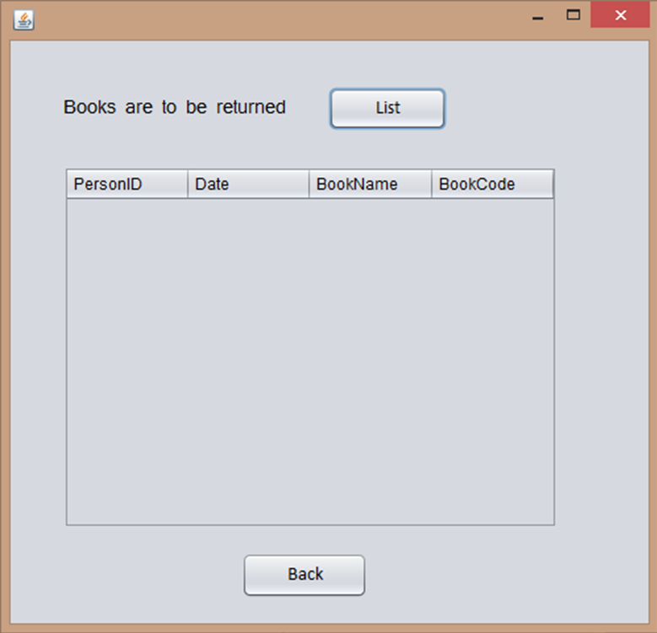

Click on the List button the you can see what are the books to be returned and other details as show in the frame.

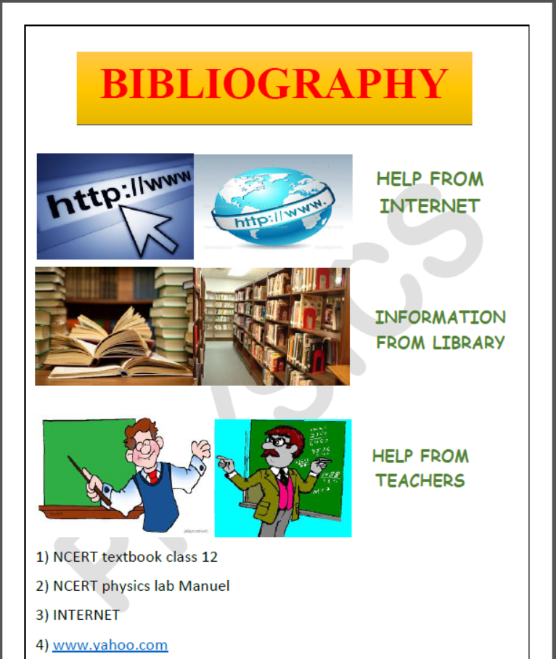

1)NCERT tectbook class 12

2)Internet

3)[www.google.com](http://www.google.com)

4)Sumit Arora guide

**THANK YOU**